Stocks Research Process
Note: Stock research process will require time and effort. But if you use this process to research a company stock you will find winners. The process I show you will give you a list of short term investments and long-term investments. There's no one perfect way to research stocks, which is why different investors choose different stocks. Analyzing stocks helps investors find the best investment opportunities. By using analytical methods when researching stocks, we can attempt to find stocks trading for a discount to their true value, which therefore will be in a great position to capture market-beating returns in the future. I hope this process will help change your financial future. God bless!!!!

- Once you identify a stock symbol or company. Go to yahoo finance. I have been using Yahoo finance for over 20 years for my research and monitoring my portfolio of stocks. Go to link below. I am using Stock symbol FLGT. This is a solid company for long term investing.

https://ca.finance.yahoo.com/quote/FLGT?p=FLGT

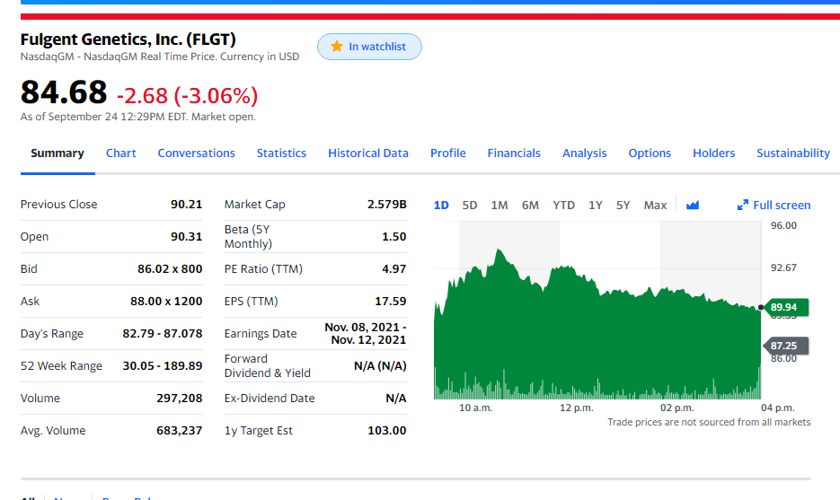
- Below is snapshot of Company FLGT. Notice the stock price which is also is real time when stock market is open. You see Stock price chart of right side. You can click 1day, 5day, 6month, 12month chart of stock price. This gives you an idea how the stock has trade over a 12month period. You also see all the stock price information and financials such as market cap stock price volume and 52 week high/low.

- You can also find some of the competitors to stock symbol FLGT. Below is snapshot. Competitors stocks on right side where you see “People also watch”. Also you will see all the latest news release for each company stock. The news release is at the bottom where you see news. These news release are valuable in understanding the company business and their financial future.
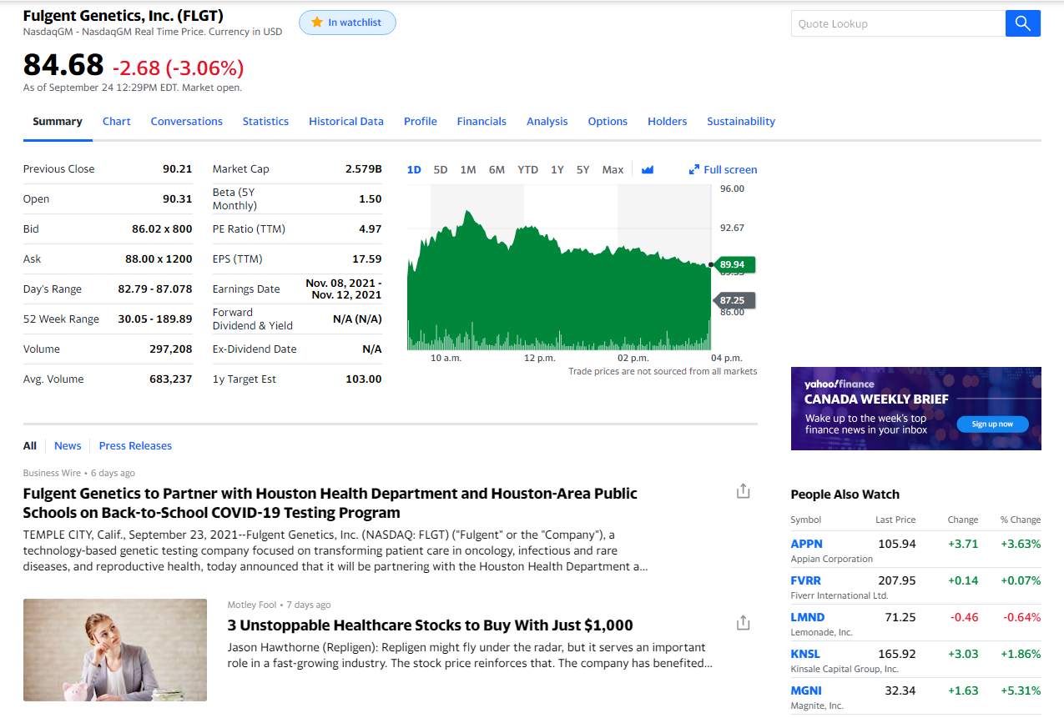

- We recommend to use Stock Charts to research a company stock symbol. You can track the stock symbol using moving averages such as 5dma, 10dma, 20dma, 50dma and 100dma. Below is link.

https://stockcharts.com/h-sc/ui

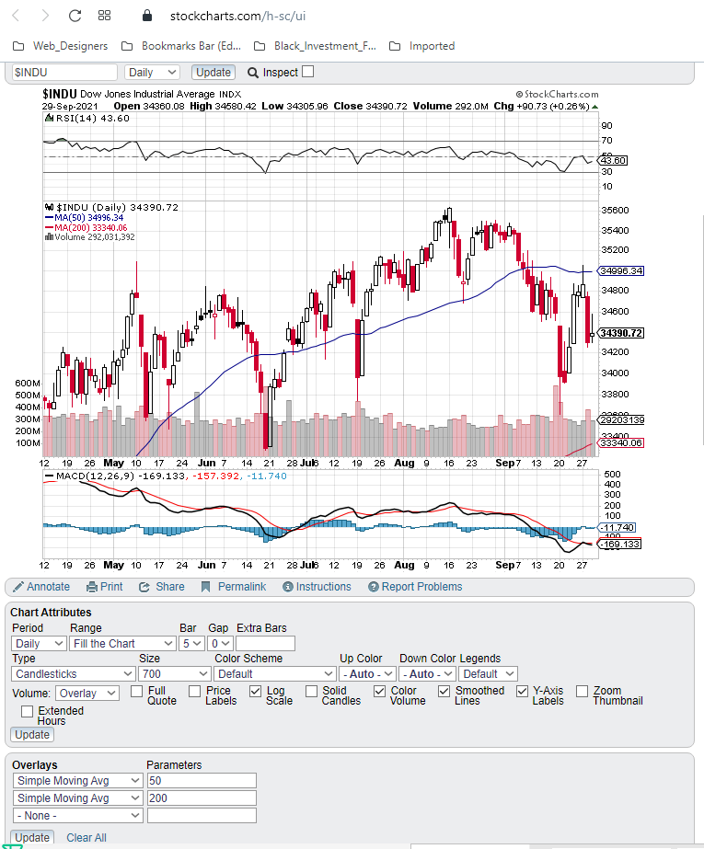

- Learn the two basic types of stock analysis
When it comes to analyzing stocks, there are two basic ways you can go: fundamental analysis and technical analysis.
- Fundamental analysis is based on the assumption that a stock price doesn't necessarily reflect the true intrinsic value of the underlying business. Fundamental analysts use valuation metrics and other information to determine whether a stock is attractively priced. Fundamental analysis is designed for investors looking for excellent long-term returns.
- Technical analysis generally assumes that a stock's price reflects all available information and that prices generally move according to trends. In other words, by analyzing a stock's price history, you may be able to predict its future price behavior. If you've ever seen someone trying to identify patterns in stock charts or discussing moving averages, that's a form of technical analysis.
- One important distinction is that fundamental analysis is intended to find long-term investment opportunities, while technical analysis typically focuses on short-term price fluctuations. We generally are advocates of fundamental analysis and believe that, by focusing on great businesses trading at fair prices, investors can beat the market over time.

- Learn some important investing metrics
With that in mind, let's take a look at four of the most important and easily understood metrics any investor should have in their analytical toolkit to understanding a company's financials:
- Price-to-earnings (P/E) ratio: Companies report their profits to shareholders as earnings per share, or EPS for short. The price-to-earnings ratio, or P/E ratio, is a company's share price divided by its annual per-share earnings. For example, if a stock trades for $30 and the company's earnings were $2 per share over the past year, we'd say it traded for a P/E ratio of 15, or "15 times earnings." This is the most common valuation metric in fundamental analysis and is useful for comparing companies in the same industry with similar growth prospects.
- Price-to-earnings-growth (PEG) ratio: Different companies grow at different rates. The PEG ratio takes a stock's P/E ratio and divides it by the expected annualized earnings growth rate over the next few years to level the playing field. For example, a stock with a P/E ratio of 20 and 10% expected earnings growth over the next five years would have a PEG ratio of 2. The idea is that a fast-growing company can be "cheaper" than a slower-growing one.
- Price-to-book (P/B) ratio: A company's book value is the net value of all of its assets. Think of book value as the amount of money a company would theoretically have if it shut down its business and sold everything it owned. The price-to-book, or P/B, ratio is a comparison of a company's stock price and its book value.
- Debt-to-EBITDA ratio: One good way to gauge financial health is by looking at a company's debt. There are several debt metrics, but the debt-to-EBITDA ratio is a good one for beginners to learn. You can find a company's total debts on its balance sheet, and you'll find its EBITDA (earnings before interest, taxes, depreciation, and amortization) on its income statement. Then turn the two numbers into a ratio. A high debt-to-EBITDA ratio could be a sign of a higher-risk investment, especially during recessions and other tough times.

- Look beyond the numbers to analyze stocks
This is perhaps the most important step in the analytical process. While everyone loves a good bargain, there's more to stock research and analysis than just looking at valuation metrics. It is far more important to invest in a good business than a cheap stock. With that in mind, here are three other essential components of stock analysis that you should watch:
- Durable competitive advantages: As long-term investors, we want to know that a company will be able to sustain (and, hopefully, grow) its market share over time. So it's important to try to identify a durable competitive advantage -- also known as an economic moat -- in the company's business model when analyzing potential stocks. This can come in several forms. A trusted brand name can give a company pricing power, patents can protect it from competitors, and a large distribution network can give it a cost advantage over peers, just to name a few.
- Great management: It doesn't matter how good a company's product is or how much growth is taking place in an industry if the wrong people are making key decisions. Ideally, the CEO and other main executives of a company will have successful and extensive industry experience and financial interests that align with shareholders'.
- Industry trends: Investors should focus on industries that have favorable long-term growth prospects. For example, over the past decade or so, the percentage of retail sales that take place online has grown from less than 5% to more than 11% today. So e-commerce is an example of an industry with a favorable growth trend. Cloud computing, payments technology, and healthcare are a few other examples of industries that are likely to grow significantly in the years ahead.

- A basic example of stock analysis
Let's quickly look at a hypothetical scenario. We'll say that I want to add a home-improvement stock to my portfolio and that I'm trying to decide between Home Depot (NYSE:HD) and Lowe's (NYSE:LOW).
First I'd take a look at some numbers. Here's how these two companies stack up in terms of some of the metrics we've discussed:
Metric | Home Depot | Lowe's
P/E ratio (last 12 months) | 26.4 | 22.9
Projected earnings growth rate | 7.1% | 20.7%
PEG ratio | 3.7 | 1.1
Debt-to-EBITDA ratio | 1.67 | 2.34
DATA SOURCES: CNBC, YCHARTS, YAHOO! FINANCE. FIGURES AS OF NOV. 5, 2020.
Here's the key takeaway from these figures. Lowe's actually appears to be the cheaper buy on both a P/E and a PEG basis. Lowe's has a higher debt-to-EBITDA multiple, so this could indicate Lowe's is the riskier of the two.

I wouldn't say that either company has a major competitive advantage over the other. Home Depot arguably has the better brand name and distribution network, but not so much that it would sway my investment decision, especially when Lowe's looks far more attractive. I'm a fan of both management teams, and the home improvement industry is one that will always be busy. If you think I'm picking a few metrics to focus on and basing my opinions on them, you're right.

- Solid analysis can help you make smart decisions. As I just mentioned, there's no one correct way to analyze stocks. The goal of stock analysis is to find companies that you believe are good values and great long-term businesses. Not only does this help you find stocks likely to deliver strong returns, but using analytical methods like those described here can help prevent you from making bad investments and losing money. Enjoy!! God Bless.

