Mental Health Improvement for Trading
Note: All of these herbs that I recommend improve your Brain functions such as memory, mental sharpness, mood and cognitive functions. These herbs will help you improve energy and manage stress better for better investing and trading. All these herbs are purchase on Amazon. I take all these herbs daily.
- Magnesium L-Threonate Powder w/Magtein for Brain Health*

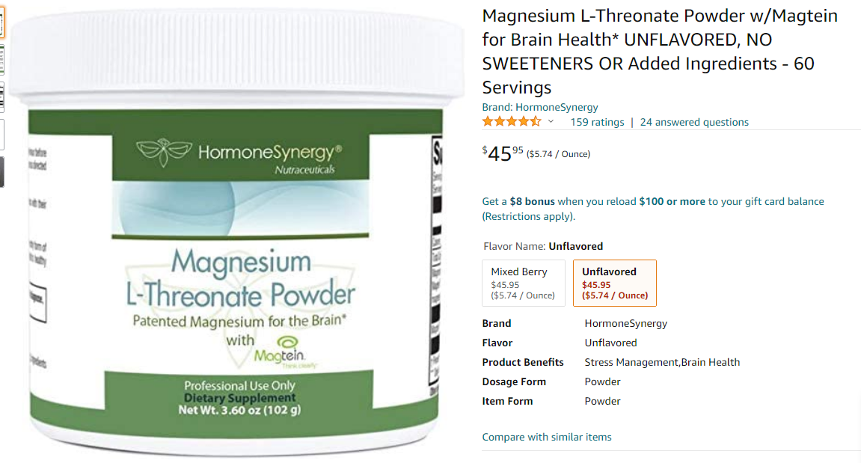

- Maximum Living MineralRich Plus Aloe Minerals Supplement - 32oz

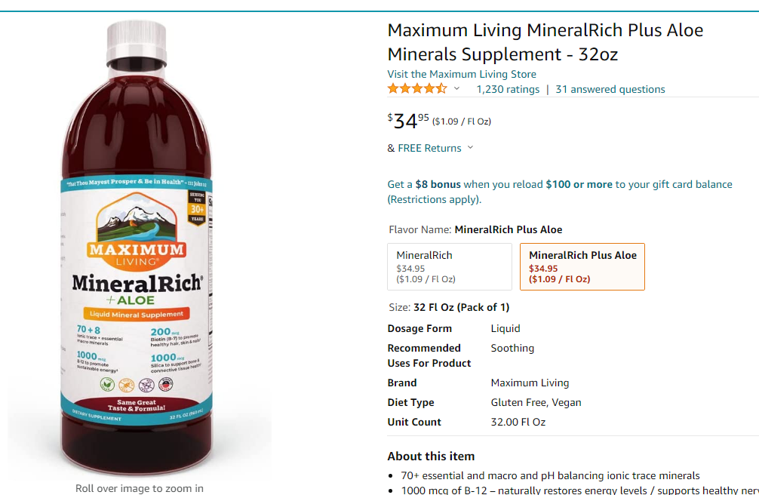

- Brain Supplement for Focus, Energy, Memory & Clarity | Nootropics Stack | by Primal Herb | Herbal Extract Powder with Lions Mane Mushroom & Reishi Spores - 82 Servings - Includes Bamboo Spoon

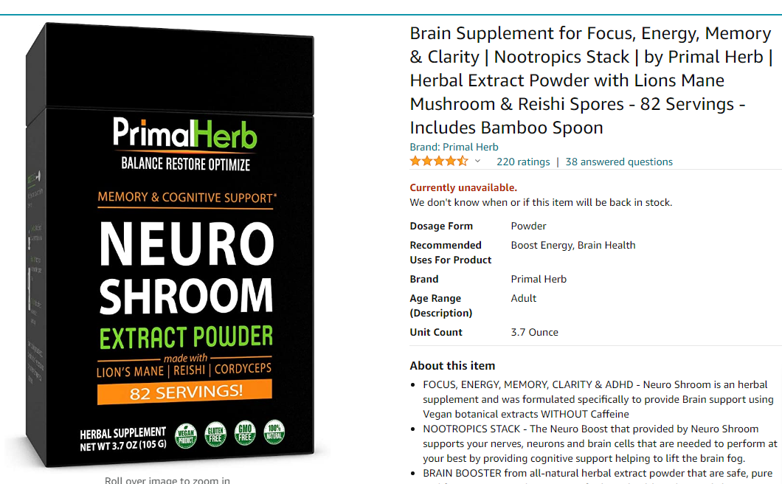

- Carlson - Elite DHA, 2270 mg DHA, Professional Strength, Norwegian Fish Oil Concentrate, Cognitive Function & Vision Support, Orange, 100 mL
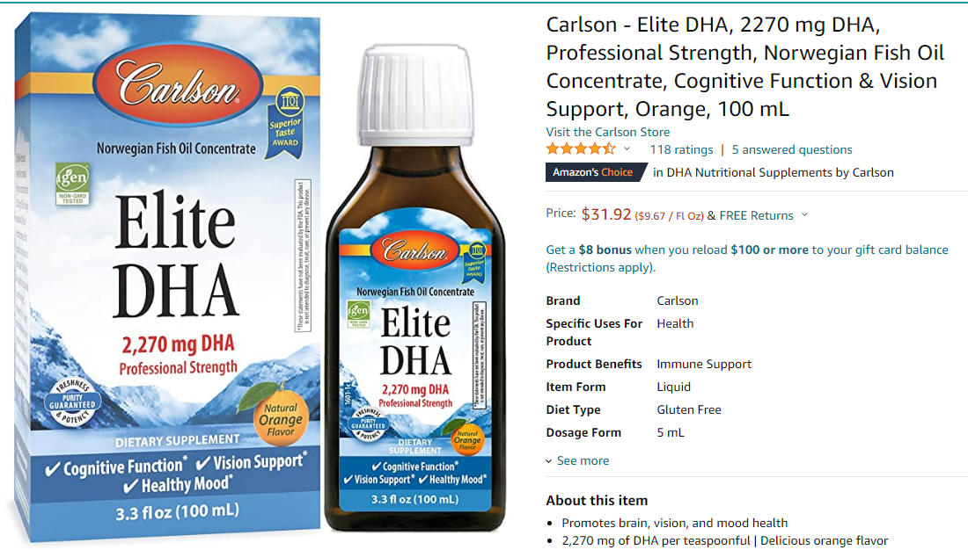
- Sun Alchemy Cognitive Coffee, Mental Focus with Organic MCT Oil, Fair-Trade Coffee, Lion’s Mane, Reishi & Chaga - 10 Sachets

